Did your ancestor serve at the Battle of Trafalgar?

If you have an inkling that your ancestor served in the British Navy at Battle of Trafalgar of 21 October 1805 then try this link to The National Archive (TNA)
http://apps.nationalarchives.gov.uk/trafalgarancestors/default.asp

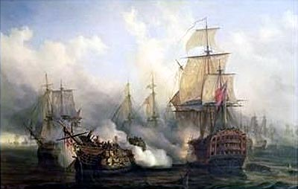

Businessman Matthew Boulton issued the Trafalgar Medal at his own expense to those who served at Trafalgar http://www.fitzmuseum.cam.ac.uk/coins/collection/watson/page49.html

Parliament did not formally recognise the achievement of Trafalgar veterans until 1847 with the introduction of the Naval General Service Medal https://www.forces-war-records.co.uk/collections/11/the-naval-general-service-medal-roll/

A history of the sailing ships of the Royal Navy can be found at http://www.ageofnelson.org/MichaelPhillips/index.html

Having traced your ancestor served at Trafalgar (above) and can provide other supporting evidence such as a family tree, possession of artifacts or letters which relate to the battle or the period, you may wish to apply to be formally recognised by the organisation Sons and Daughters of Trafalgar. Applications should be made to organisation's registrar Peter Hore.

Gordon P MARTIN
Membership No 1210

